*The Binding of Isaac: Gameplay Guide – User Guide*

The Binding of Isaac Gameplay Guide is used to help the gamer learn more about the games items, floors, rooms and characters. This user guide will help you navigate the user interface of the application.

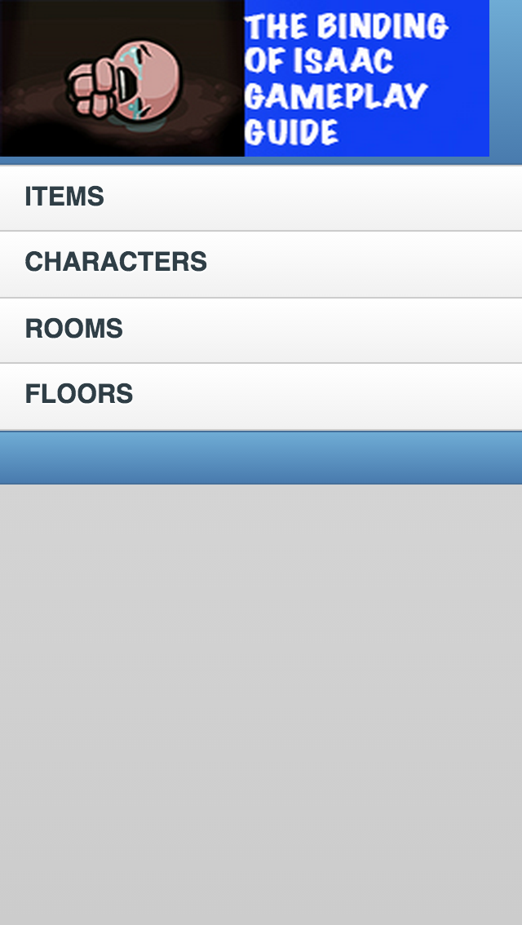

HOME PAGE:

The first screen of the app has 4 links to different pages that can be accessed. The banner is at the top with copyright at the bottom.

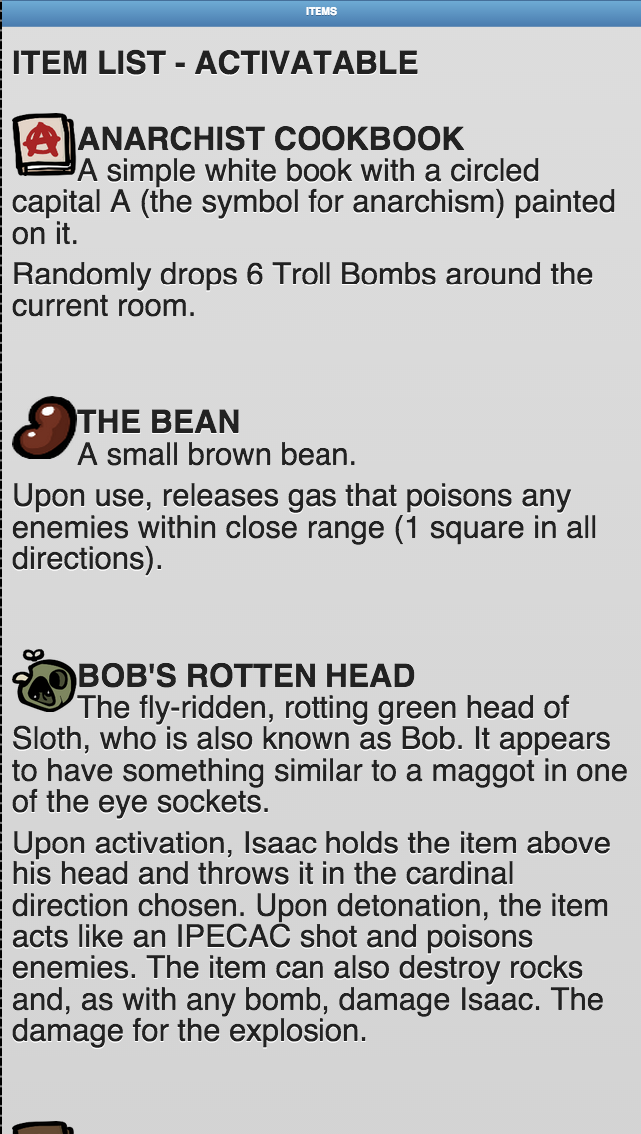

ITEM PAGE:

The item page can be accessed from the home page to access information about items in the game.

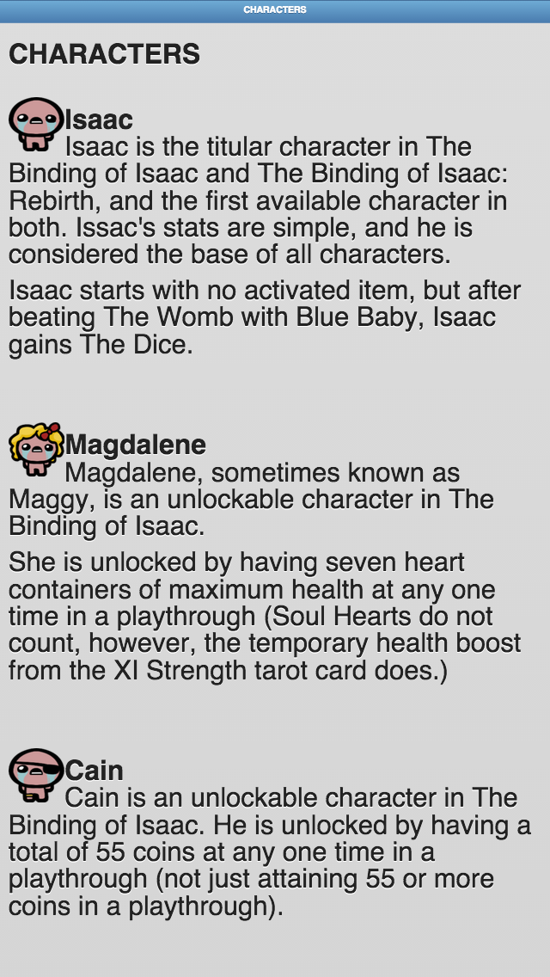CHARACTERS PAGE:

The character page can be accessed from the home page to access information about the characters in the game.

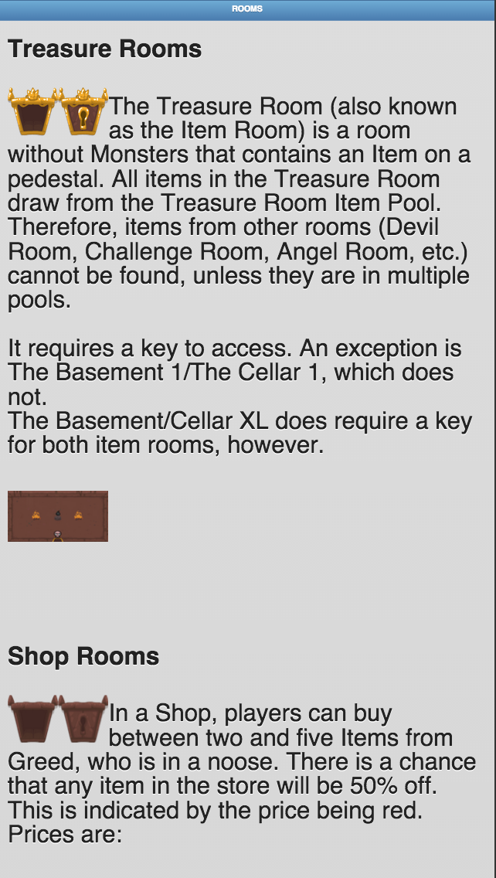

ROOMS PAGE:

The room’s page can be accessed from the home page to access information about the rooms in the game.

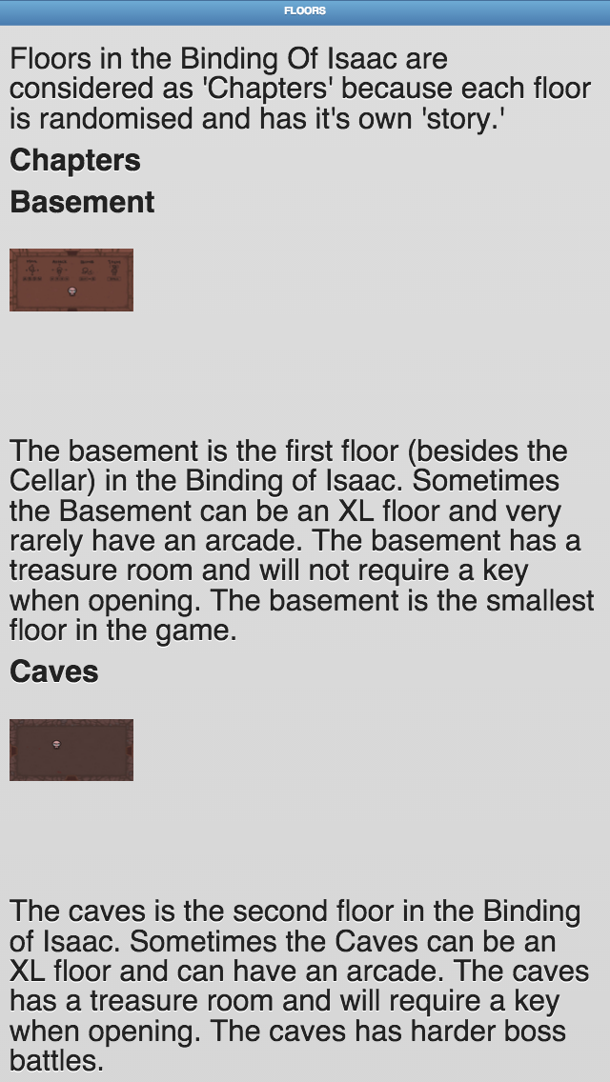

FLOORS PAGE:

The floor page can be accessed from the home page to access information about the rooms in the game.

FEATURES:

The Binding of Isaac: Gameplay Guide has multiple luxury features such as crossfade between pages and a back button on each page (excluding the home page) so you can navigate easily with smooth transitions.